Analog Signal Conditioning
Signal conditioning refers to operations performed on signals to convert them to a form suitable for interface with other elements in the digital circuits. The primary purpose for the analog signal conditioning circuitry is to modify the sensor output into a form that can be optimally converted to a discrete time digital data stream by the data acquisition system.
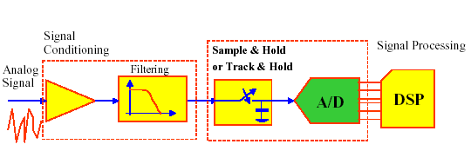
• It is possible to categorize signal conditioning into several general types.

(a) Signal-level Changes
The simplest type of signal conditioning is to change the level of a signal. The most common example is the necessity to either amplify or attenuate a voltage level.
– amplification: raise milivolt signals to volts

Linearization

Process control engineer has little choice of the characteristics of a sensor output versus a process variable . Often the dependence that exists between input and output is nonlinear. Historically, analog devices and circuits were used to linearize signals.

Linearization by equation:

When an equation is known that relates the value of the measured value and the binary number in the computer, an equation can be developed to determine the linearized value of the variable. The modern approach to this problem is linearization by using software. Look up method is one of linearization methods in microprocessor based systems. Linearization is to maximize the linearity of a transducer’s response. Figure shows a software approaches for look up table in flowchart format. It is assumed that the input values are stored in ascending value in N memory locations. If the input is found at the Ith memory location from the start of table, the actual variable value is found at the N+I location. There are other type of look up table applications in microprocessor applications.

Filtering and Impedance Matching

In many cases, it is necessary to use high-pass, low-pass, or notch filters to eliminate unwanted signals from the loop. Such filtering can be accomplished by
(a) passive filters using only resistors, inductors, capacitors, or
(b) active filters using op amps.
– filtering : remove frequencies above Nyquist Frequency
Impedance matching is an important element of signal conditioning when transducer internal impedance or line impedance can cause errors in measurement of a dynamic variable.

– electrical isolation: protect computer from high voltages
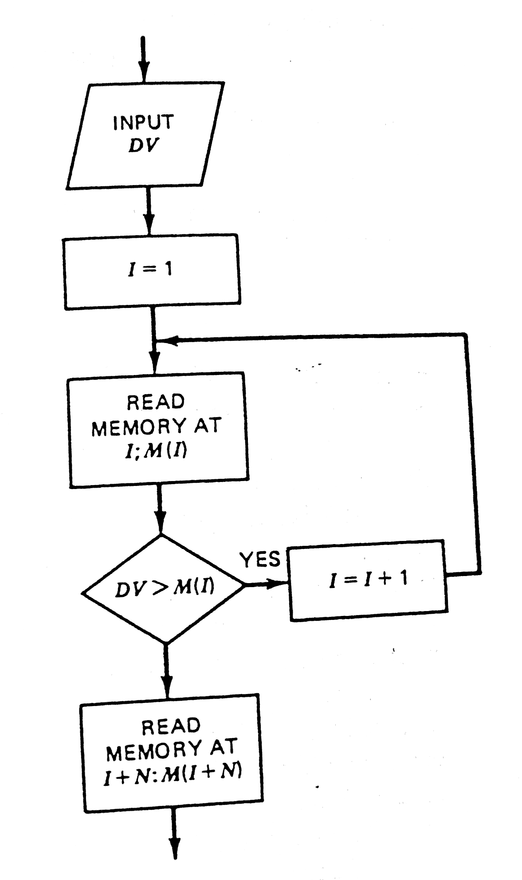

Look up table based sensor linearization
Passive Circuits

Bridges and divider circuits are passive networks that have been used extensively for signal conditioning.
- Divider Circuit
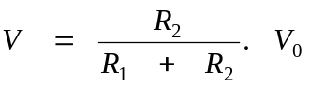 | 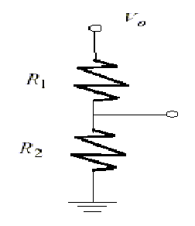
Figure (1)

Bridges:

  A set of accurately known impedance is adjusted in value in relation to an unknown until the potential difference between two points is zero.  This condition defines an equation used to find the unknown impedance in terms of the known values.  Such measurement techniques are based on reaching the null condition, i.e., zero voltage or current of the measurement branch.

Whetstone Bridge

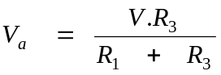 (2)
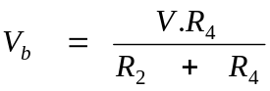 (3)
Combining equations (1), (2) and (3), we have
A particular combination of resistor can be found that will result in zero difference and zero voltage across the detector, that is null:

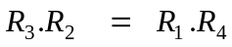 (4)

Whenever a Wheatstone bridge is assembled and resistors are adjusted for a detector null, the resistor values must satisfy the equality.
It does not matter if the supply voltage drifts or changes, the null is maintained.

Ex: If the Wheatstone bridge nulls with R₁ = 1 kΩ, R₂ = 842 Ω, R₃ = 500 Ω, find the value of R₄.

Application of Wheatstone Bridge:

‘’Because of its outstanding sensitivity, the Wheatstone bridge circuit is the most frequently used circuit for sensor output measurements.’’ The simple bridge is shown in figure(3). With no change in physical condition ΔR = 0, all four resistor are equal, +out = -out, so V_{out} = 0. When the sensing changes, the sensor resistance changes by ΔR.

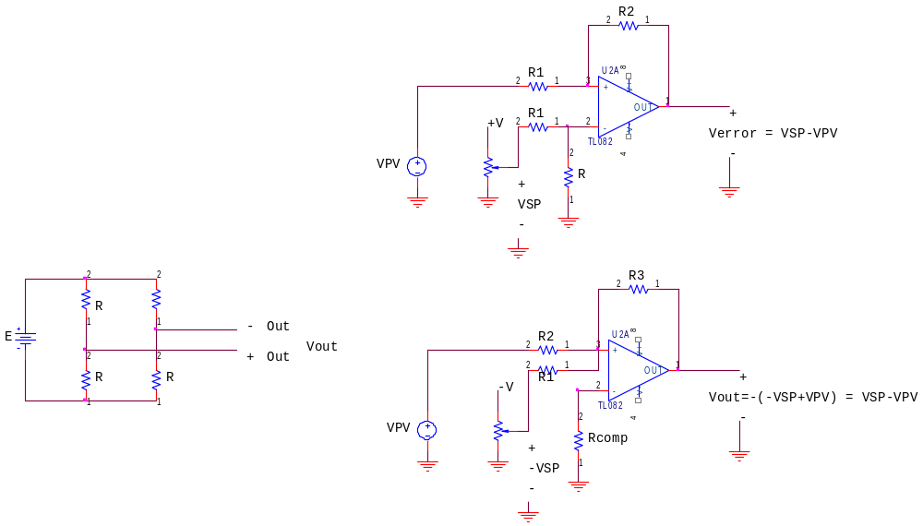
R+∆R

Figure (3)

Since ΔR, the effect of the variable, is in both the numerator and the denominator of equation, the output of the bridge changes nonlinearity with applied force. However, R is several hundred ohms while ΔR is typically 0.01Ω, a factor of 10.000 times smaller. So since

4R >> 2ΔR

can be rewritten, dropping the 2 ΔR from the denominator,
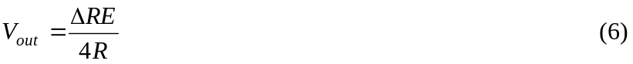

Do not forget that Vout is differential. It is not ground referenced. This signal must be amplified by a circuit with a very large input impedance and the ability to output a ground referenced signal which depends solely on the difference between its two inputs (+out and –out of the bridge). Strain gage (force sensor) for sensing of stress can be used with Wheatstone Bridge Circuit.

Use of potentiometers in measurement

There are several ways to connect potentiometers into a control system. The simplest is to drive one end with a ground-referenced voltage, and ground the other end. This is shown in Figure 1-a. this causes zero volts out when the wiper has been driven all the way to the bottom, and V_{supply} out when the wiper is at the top. See Figure(4). This configuration is useful if the wiper is not driven to the extremes of the potentiometer. The zero adjustment allows you to place zero volts at whatever position on the potentiometer you desire. Similarly, the full-scale adjustment lets you calibrate the output voltage to some convenient value when the wiper has been driven as far up as it will be. Several iteration of increasing finer adjustment will be necessary, since these two adjustments are interdependent.

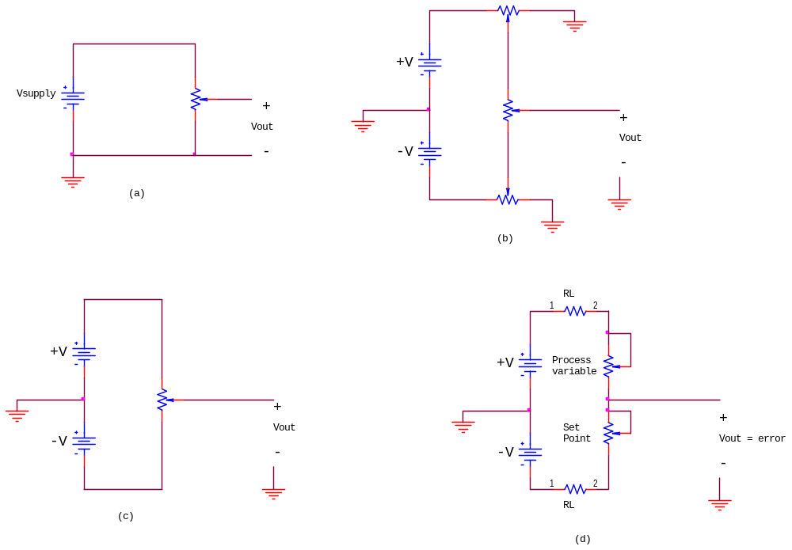
+V
+V
+V

Figure(4)

Driving both ends of the potentiometer places zero volts in the center of the potentiometer. This is shown Figure 4-c. A modification of this can be used to produce a ground-referenced error signal for use by a controller. Look at Figure 4-d. The set point is a potentiometer located on a control panel. The process variable is driven by the parameter being measured. Error is defined as

Error = SP - PV

